1. Overview
The Google Drive API allows developers to integrate Google Drive's cloud storage capabilities into their applications. It enables users to upload, download, search, share, and manage files programmatically.
The API follows REST principles and exchanges data using the JSON format, making it easy to integrate with modern web and mobile applications.

2. Intended Audience
This guide is intended for:
- Students
- Beginner developers
- Technical writers
- AI and Machine Learning learners
- Web developers

3. Prerequisites
Before using the Google Drive API, ensure that you have:
- A Google account
- A Google Cloud project
- A stable internet connection
- Basic understanding of REST APIs
- Basic programming knowledge (recommended)

TW – 005

Getting Started with the
Google Drive API
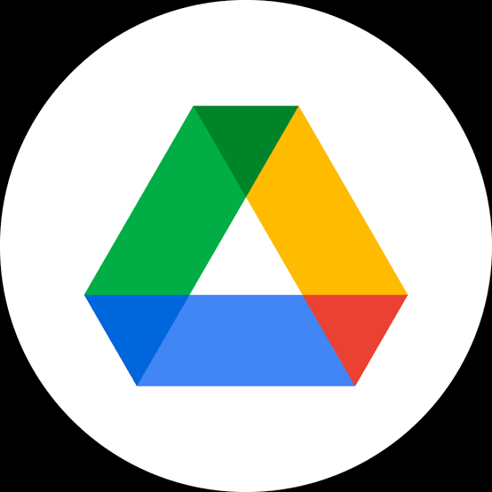

Document ID: TW-005
Author: Swetha

Date: 09-07-2026

4. Key Features
Feature | Description
  File Upload | Upload files to Google Drive.
  File Download | Download files stored in Google Drive.
  File Search | Search for files and folders using queries.
  Folder Management | Create, update, and organize folders.
  Sharing | Share files and manage user permissions.

5. Authentication
The Google Drive API uses OAuth 2.0 for secure authorization.
You can authenticate using one of the following methods:

OAuth 2.0

Used when applications access Google Drive on behalf of a user.
API Key

Suitable for limited public data access where user authorization is not required.
Service Account
Recommended for server-to-server communication without direct user interaction.

6. Making Your First API Request
Base URL https://www.googleapis.com/drive/v3/
HTTP Method GET
Endpoint files
Description Retrieves a list of files stored in Google Drive.



Example Response (Truncated)
{
"files": [
{
"id": "1a2b3c4d5e6f",
"name": "Document.pdf"
}
]
}
Example Request
GET https://www.googleapis.com/drive/v3/files
?pageSize=10&fields=files(id,name)

Code | Meaning
200 | Request successful
400 | Bad request
401 | Unauthorized
403 | Forbidden
404 | Resource not found
500 | Internal server error
7. Common HTTP Status Codes
8. Best Practices
- Protect API credentials and OAuth tokens.
- Request only the permissions your application requires.
- Handle errors gracefully with meaningful messages.
- Monitor API usage and quota limits.
- Use HTTPS for all API requests.

9. Troubleshooting
Issue | Solution
Authentication failed | Verify OAuth credentials and token validity.
Access denied | Ensure the required API permissions are enabled.
Invalid request | Review the request URL and parameters.
Quota exceeded | Wait for the quota to reset or request a higher quota.

10. Summary
The Google Drive API enables applications to securely store, retrieve, and manage files within Google Drive. By using OAuth 2.0 authentication and standard HTTP requests, developers can build reliable integrations that improve productivity and collaboration.


Note: Always protect API keys, OAuth tokens, and service account credentials. Never expose sensitive credentials in public repositories or share them with unauthorized users.

